Canon Printers & Copiers
Canon imageRUNNER ADVANCE C3520i
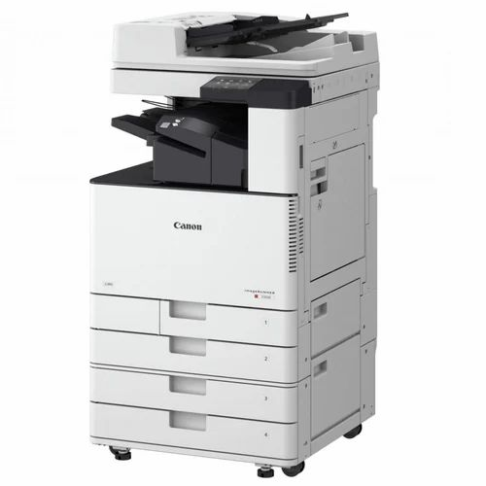
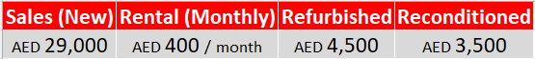
- Print Speed: 20 ppm
- Print / Copy / Scan / Fax
- Paper Size: A3, A4
- Duplex Printing, Network Ready
- Max Capacity: 2300 sheets
- Display: 10.1" Colour Touchscreen
- Weight: ~81.5 kg
- Duty Cycle: 100,000 copies/month

Canon imageRUNNER ADVANCE C5540i

- Print Speed: 40 ppm
- Print / Copy / Scan / Fax
- Paper Size: A3, A4
- Duplex Printing, Network Ready
- Max Capacity: 6350 sheets
- Display: 10.1" Colour Touchscreen
- Weight: ~142 kg
- Duty Cycle: 145,000 copies/month

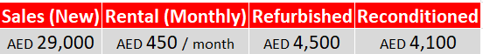
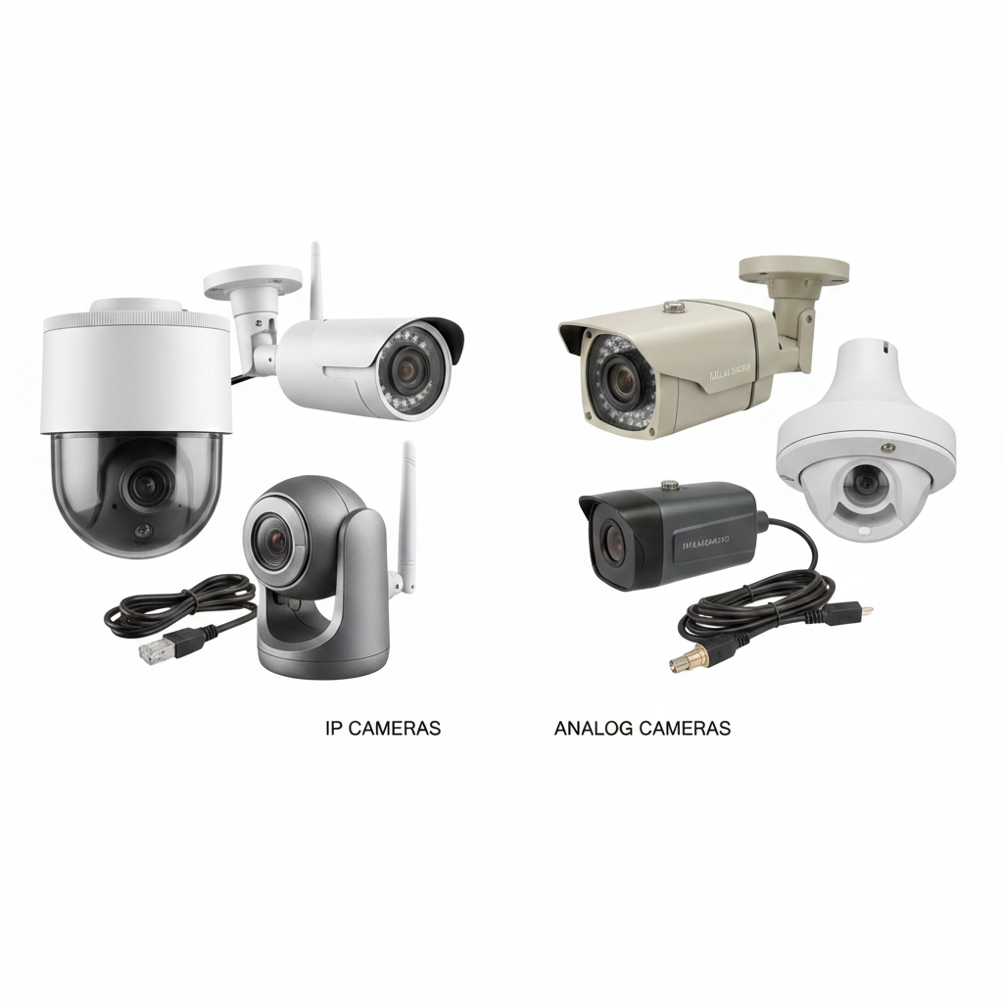
CCTV & Security Solutions
IP (Network) Cameras
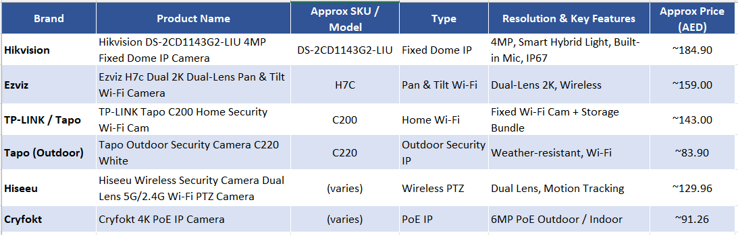
- One-Cable Setup: Uses a single Ethernet cable for both power and data (PoE).
- High Detail: Delivers superior 4K/Ultra-HD resolution for clear digital zooming.
- Smart AI: Features built-in detection for people, vehicles, and faces.
- Cloud Ready: Can save footage directly to the internet or an internal SD card.
- Remote View: Easily accessible from anywhere via a mobile app without extra gear.

CCTV & Security Solutions

Analog (CCTV) Cameras
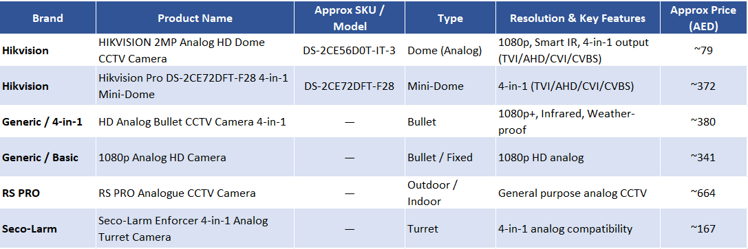
- Low Cost: The most budget-friendly option for simple security setups.
- Zero Lag: Video transmits instantly with no network delay or "freezing."
- Easy Install: Simple "plug-and-play" setup that doesn't require a network expert.
- Long Range: Works reliably over very long distances using standard coaxial cables.
- High Reliability: Records 24/7 regardless of your internet or Wi-Fi stability.

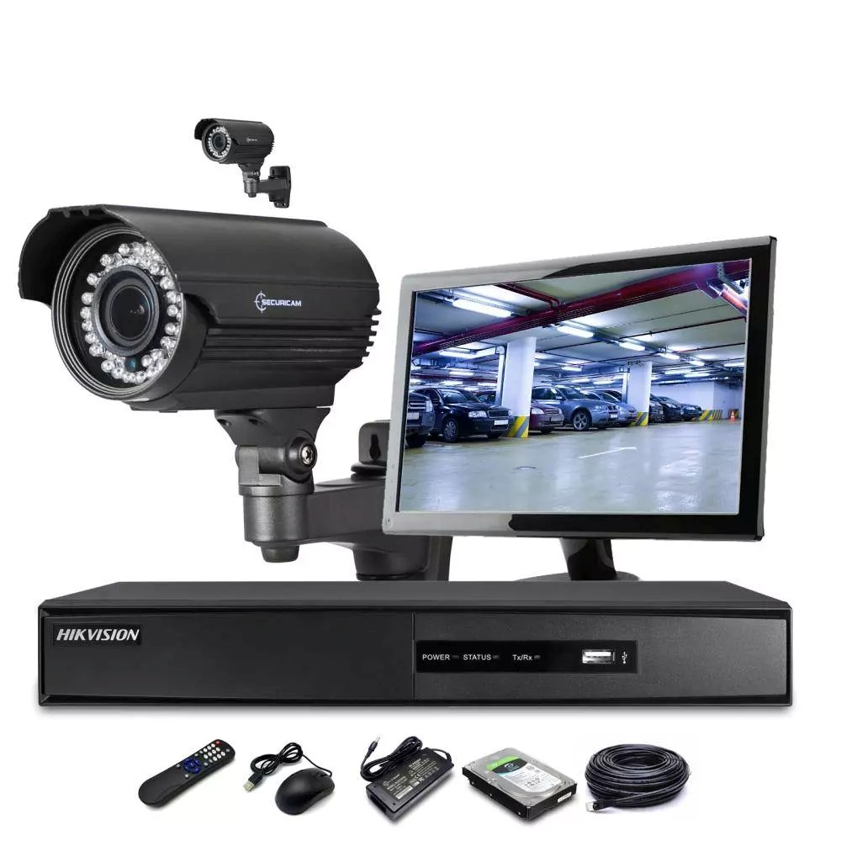
CCTV & Security Solutions
CCTV Kits
- DVR (Digital Video Recorder) – central recording unit with multiple channels (e.g., 4-16) for cameras.
- Cameras – anywhere from 2 to 16+, typically a mix of bullet & dome styles.
- HDD (Hard Drive) – for local video storage (some kits include 1 TB or more).
- Cabling, Adapters & Power Supplies – everything needed for basic install.
- Night Vision & Weatherproof Cameras – common for outdoor use.

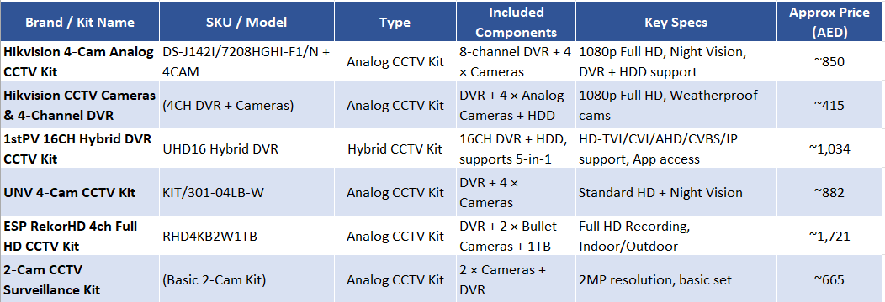

CCTV & Security Solutions
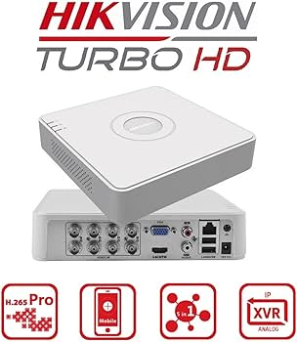
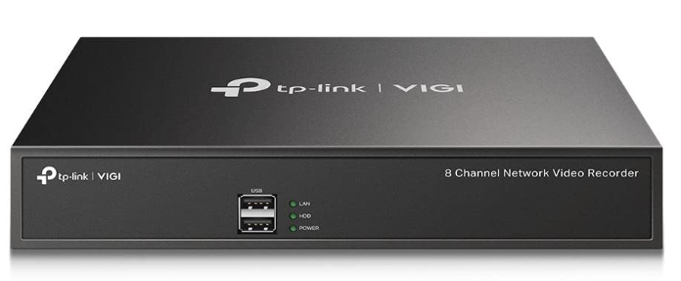
NVR Systems
DVR Systems
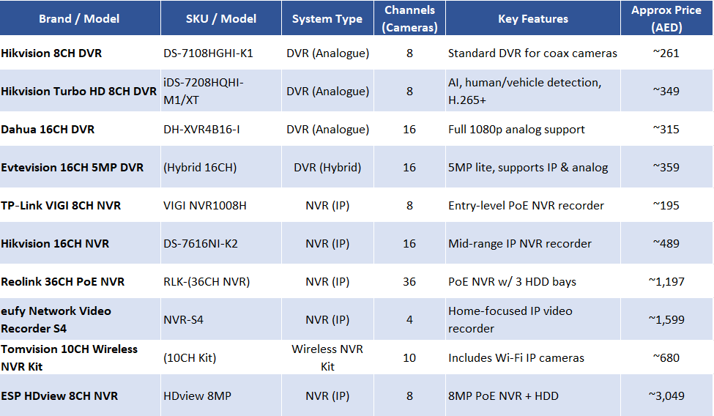
- Camera Type: Analog Cameras
- Video Quality: HD TVI/AHD/CVI
- Cabling: Coax + Separate power cables
- Installation: More Complex Wiring
- Feature Set: Basic Functionality
- Use Cases: Legacy or budget CCTV
- Camera Type: IP Cameras
- Video Quality: HD/4K
- Cabling: Ethernet (Cat5e/Cat6), POE
- Installation: Single Cable
- Feature Set: Better Analytics
- Use Cases: Modern Network Surveillance
AMC & Services
- Preventive Maintenance (Scheduled)
- Corrective Maintenance (Breakdown Support)
- System Performance Monitoring
- Remote Support Services
- Emergency & On-Call Support
- Reporting & Documentation
- CCTV Installation Support
- Alarm Systems Setup
- Annual Maintenance Contracts

